***University Physics Volume I***

**Unit 1: Mechanics**

**Chapter 3: Motion Along a Straight Line**

**Conceptual Questions**

1. Give an example in which there are clear distinctions among distance traveled, displacement, and magnitude of displacement. Identify each quantity in your example specifically.

Solution

You drive your car into town and return to drive past your house to a friend’s house.

1. Under what circumstances does distance traveled equal magnitude of displacement? What is the only case in which magnitude of displacement and distance are exactly the same?

Solution

When the velocity is in the positive direction and doesn’t reverse direction. They are both the same if the velocity is in the positive direction and does not reverse direction.

1. Bacteria move back and forth using their flagella (structures that look like little tails). Speeds of up to 50 μm/s (50 × 10−6 m/s) have been observed. The total distance traveled by a bacterium is large for its size, whereas its displacement is small. Why is this?

Solution

If the bacteria are moving back and forth, then the displacements are canceling each other and the final displacement is small.

1. Give an example of a device used to measure time and identify what change in that device indicates a change in time.

Solution

A stopwatch with a digital display

1. Does a car’s odometer measure distance traveled or displacement?

Solution

Distance traveled

1. During a given time interval the average velocity of an object is zero. What can you conclude about its displacement over the time interval?

Solution

The displacement is zero.

1. There is a distinction between average speed and the magnitude of average velocity. Give an example that illustrates the difference between these two quantities.

Solution

Average speed is the total distance traveled divided by the elapsed time. If you go for a walk, leaving and returning to your home, your average speed is a positive number. Since Average velocity = Displacement/Elapsed time, your average velocity is zero.

1. Does the speedometer of a car measure speed or velocity?

Solution

speed

1. If you divide the total distance traveled on a car trip (as determined by the odometer) by the elapsed time of the trip, are you calculating average speed or magnitude of average velocity? Under what circumstances are these two quantities the same?

Solution

Average speed. They are the same if the car doesn’t reverse direction.

1. How are instantaneous velocity and instantaneous speed related to one another? How do they differ?

Solution

Instantaneous speed is the absolute value or magnitude of instantaneous velocity. Instantaneous speed is always a positive number whereas instantaneous velocity can be both positive and negative because it gives direction.

1. Is it possible for speed to be constant while acceleration is not zero?

Solution

No, in one dimension constant speed requires zero acceleration.

1. Is it possible for velocity to be constant while acceleration is not zero? Explain.

Solution

No, acceleration is change in velocity.

1. Give an example in which velocity is zero yet acceleration is not.

Solution

A ball is thrown into the air and its velocity is zero at the apex of the throw, but acceleration is not zero.

1. If a subway train is moving to the left (has a negative velocity) and then comes to a stop, what is the direction of its acceleration? Is the acceleration positive or negative?

Solution

Positive and to the right

1. Plus and minus signs are used in one-dimensional motion to indicate direction. What is the sign of an acceleration that reduces the magnitude of a negative velocity? Of a positive velocity?

Solution

Plus, minus

1. When analyzing the motion of a single object, what is the required number of known physical variables that are needed to solve for the unknown quantities using the kinematic equations?

Solution

three, since each equation has four unknowns.

1. State two scenarios of the kinematics of single object where three known quantities require two kinematic equations to solve for the unknowns.

Solution

If the acceleration, time, and displacement are the knowns, and the initial and final velocities are the unknowns, then two kinematic equations must be solved simultaneously. Also if the final velocity, time, and displacement are the knowns then two kinematic equations must be solved for the initial velocity and acceleration.

1. What is the acceleration of a rock thrown straight upward on the way up? At the top of its flight? On the way down? Assume there is no air resistance.

Solution

In all cases the acceleration is 9.8 m/s2 downward.

1. An object that is thrown straight up falls back to Earth. This is one-dimensional motion. (a) When is its velocity zero? (b) Does its velocity change direction? (c) Does the acceleration have the same sign on the way up as on the way down?

Solution

a. at the top of its trajectory; b. yes, at the top of its trajectory; c. yes

1. Suppose you throw a rock nearly straight up at a coconut in a palm tree and the rock just misses the coconut on the way up but hits the coconut on the way down. Neglecting air resistance and the slight horizontal variation in motion to account for the hit and miss of the coconut, how does the speed of the rock when it hits the coconut on the way down compare with what it would have been if it had hit the coconut on the way up? Is it more likely to dislodge the coconut on the way up or down? Explain.

Solution

The speed is the same in both cases. It has equal probability of dislodging the coconut on the way up and way down.

1. The severity of a fall depends on your speed when you strike the ground. All factors but the acceleration from gravity being the same, how many times higher could a safe fall occur on the Moon than on Earth (gravitational acceleration on the Moon is about one-sixth that of the Earth)?

Solution

Earth ; Moon ; Earth  Moon 

1. How many times higher could an astronaut jump on the Moon than on Earth if her takeoff speed is the same in both locations (gravitational acceleration on the Moon is about on-sixth of that on Earth)?

Solution

Earth ; set  Moon ; set  Earth  Moon ; 

1. When given the acceleration function, what additional information is needed to find the velocity function and position function?

Solution

We must know the initial conditions on the velocity and position at *t* = 0 to solve for the constants of integration.

**Problems**

1. Consider a coordinate system in which the positive *x* axis is directed upward vertically. What are the positions of a particle (a) 5.0 m directly above the origin and (b) 2.0 m below the origin?

Solution

a. 5.0 m, b. –2.0 m

1. A car is 2.0 km west of a traffic light at *t* = 0 and 5.0 km east of the light at *t* = 6.0 min. Assume the origin of the coordinate system is the light and the positive *x* direction is eastward. (a) What are the car’s position vectors at these two times? (b) What is the car’s displacement between 0 min and 6.0 min?

Solution

a. , ; b.  east

1. The Shanghai maglev train connects Longyang Road to Pudong International Airport, a distance of 30 km. The journey takes 8 minutes on average. What is the maglev train’s average velocity?

Solution



1. The position of a particle moving along the *x*-axis is given by m. (a) At what time does the particle cross the origin? (b) What is the displacement of the particle between  and 

Solution

a.  s; b. 

1. A cyclist rides 8.0 km east for 20 minutes, then he turns and heads west for 8 minutes and 3.2 km. Finally, he rides east for 16 km, which takes 40 minutes. (a) What is the final displacement of the cyclist? (b) What is his average velocity?

Solution

a.  b. 

1. On February 15, 2013, a superbolide meteor (brighter than the Sun) entered Earth’s atmosphere over Chelyabinsk, Russia, and exploded at an altitude of 23.5 km. Eyewitnesses could feel the intense heat from the fireball, and the blast wave from the explosion blew out windows in buildings. The blast wave took approximately 2 minutes 30 seconds to reach ground level. The blast wave traveled at 10above the horizon. (a) What was the average velocity of the blast wave? (b) Compare this with the speed of sound, which is 343 m/s at sea level.

Solution

a.   b. 163% the speed of sound at sea level or about Mach 2.

1. A woodchuck runs 20 m to the right in 5 s, then turns and runs 10 m to the left in 3 s. (a) What is the average velocity of the woodchuck? (b) What is its average speed?

Solution

a.  where  and   b. 

1. Sketch the velocity-versus-time graph from the following position-versus-time graph.

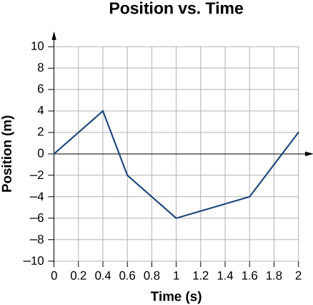

Solution

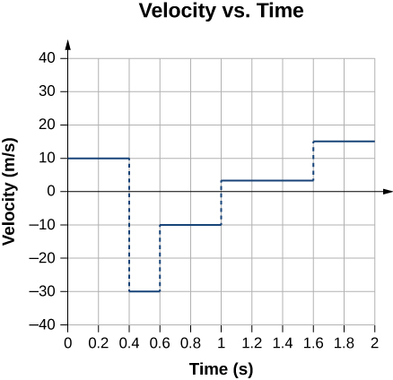

1. Sketch the velocity-versus-time graph from the following position-versus-time graph.

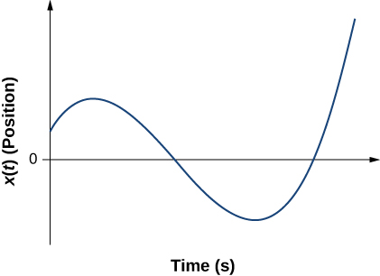

Solution

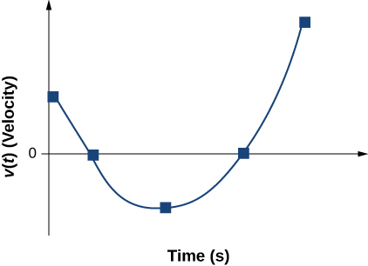

1. Given the following velocity-versus-time graph, sketch the position-versus-time graph.

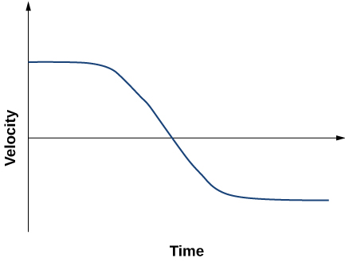

Solution

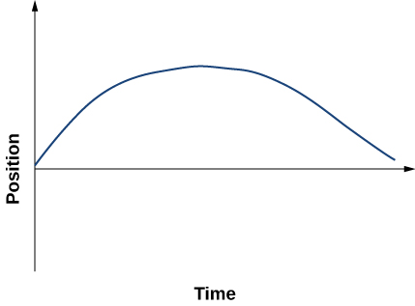

1. An object has a position function *x*(*t*) = 5*t* m. (a) What is the velocity as a function of time? (b) Graph the position function and the velocity function.

Solution

 The position function is a line with slope 5 that passes through the origin. The velocity function is a straight line with slope zero and a *y*-intercept of 5.

1. A particle moves along the *x-*axis according to  (a) What is the instantaneous velocity at *t* = 2 s and *t* = 3 s? (b) What is the instantaneous speed at these times? (c) What is the average velocity between *t* = 2 s and *t* = 3 s?

Solution

a.  *v*(2 s) = 2 m/s, *v*(3 s) = –2 m/s; b.  (c) 

1. **Unreasonable results.** A particle moves along the *x*-axis according to  At what time is the velocity of the particle equal to zero? Is this reasonable?

Solution

 Setting *v*(*t*) = 0 gives  which is not a real number, so the particle never has a velocity equal to zero.

1. A cheetah can accelerate from rest to a speed of 30.0 m/s in 7.00 s. What is its acceleration?

Solution



1. Dr. John Paul Stapp was a U.S. Air Force officer who studied the effects of extreme acceleration on the human body. On December 10, 1954, Stapp rode a rocket sled, accelerating from rest to a top speed of 282 m/s (1015 km/h) in 5.00 s and was brought jarringly back to rest in only 1.40 s. Calculate his (a) acceleration in his direction of motion and (b) acceleration opposite to his direction of motion. Express each in multiples of *g* (9.80 m/s2) by taking its ratio to the acceleration of gravity.

Solution

a. 

b. 

1. Sketch the acceleration-versus-time graph from the following velocity-versus-time graph.

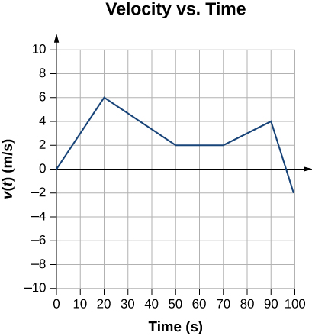

Solution

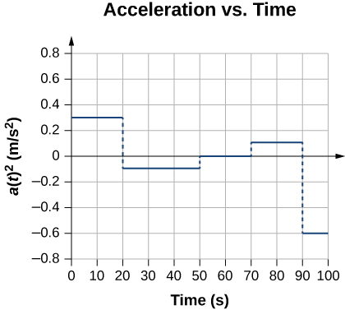

1. A commuter backs her car out of her garage with an acceleration of 1.40 m/s2. (a) How long does it take her to reach a speed of 2.00 m/s? (b) If she then brakes to a stop in 0.800 s, what is her acceleration?

Solution

a.  b. 

1. Assume an intercontinental ballistic missile goes from rest to a suborbital speed of 6.50 km/s in 60.0 s (the actual speed and time are classified). What is its average acceleration in meters per second squared and in multiples of *g* (9.80 m/s2)?

Solution



1. An airplane, starting from rest, moves down the runway at constant acceleration for 18 s and then takes off at a speed of 60 m/s. What is the average acceleration of the plane?

Solution



1. A particle moves in a straight line at a constant velocity of 30 m/s. What is its displacement between t = 0 and t = 5.0 s?

Solution

150 m

1. A particle moves in a straight line with an initial velocity of 0 m/s and a constant acceleration of 30 m/s2. If *x* = 0 at *t* = 0, what is the particle’s position at *t* = 5 s?

Solution



1. A particle moves in a straight line with an initial velocity of 30 m/s and constant acceleration 30 m/s2. (a) What is its displacement at *t* = 5 s? (b) What is its velocity at this same time?

Solution

a. 

b. 

1. (a) Sketch a graph of velocity versus time corresponding to the graph of displacement versus time given in the following figure. (b) Identify the time or times (*t*a, *t*b, *t*c, etc.) at which the instantaneous velocity has the greatest positive value. (c) At which times is it zero? (d) At which times is it negative?

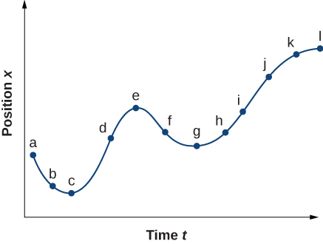

Solution

a.

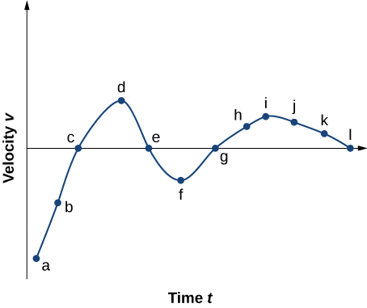

b. The instantaneous velocity has the greatest positive value at 

c. The instantaneous velocity is zero at 

d. The instantaneous velocity is negative at 

1. (a) Sketch a graph of acceleration versus time corresponding to the graph of velocity versus time given in the following figure. (b) Identify the time or times (*t*a, *t*b, *t*c, etc.) at which the acceleration has the greatest positive value. (c) At which times is it zero? (d) At which times is it negative?

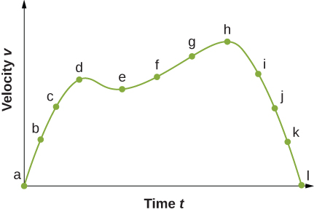

Solution

a.

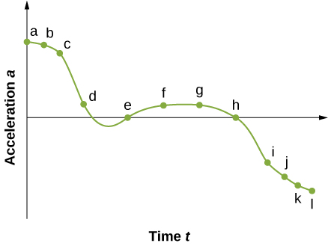

b. The acceleration has the greatest positive value at 

c. The acceleration is zero at 

d. The acceleration is negative at 

1. A particle has a constant acceleration of 6.0 m/s2. (a) If its initial velocity is 2.0 m/s, at what time is its displacement 5.0 m? (b) What is its velocity at that time?

Solution

a.  

b. 

1. At *t* = 10 s, a particle is moving from left to right with a speed of 5.0 m/s. At *t* = 20 s, the particle is moving right to left with a speed of 8.0 m/s. Assuming the particle’s acceleration is constant, determine (a) its acceleration, (b) its initial velocity, and (c) the instant when its velocity is zero.

Solution

a. 

b.  or 

c. 

1. A well-thrown ball is caught in a well-padded mitt. If the acceleration of the ball is, and 1.85 ms  elapses from the time the ball first touches the mitt until it stops, whatis the initial velocity of the ball?

Solution

 or about 87 mi/h

1. A bullet in a gun is accelerated from the firing chamber to the end of the barrel at an average rate of  for  What is its muzzle velocity (that is, its final velocity)?

Solution



1. (a) A light-rail commuter train accelerates at a rate of 1.35 m/s2. How long does it take to reach its top speed of 80.0 km/h, starting from rest? (b) The same train ordinarily accelerates opposite to the motion at a rate of 1.65 m/s2. How long does it take to come to a stop from its top speed? (c) In emergencies, the train can accelerates opposite to the motion more rapidly, coming to rest from 80.0 km/h in 8.30 s. What is its emergency acceleration in meters per second squared?

Solution

a. 

b.  c. 

1. While entering a freeway, a car accelerates from rest at a rate of 2.40 m/s2 for 12.0 s. (a) Draw a sketch of the situation. (b) List the knowns in this problem. (c) How far does the car travel in those 12.0 s? To solve this part, first identify the unknown, then indicate how you chose the appropriate equation to solve for it. After choosing the equation, show your steps in solving for the unknown, check your units, and discuss whether the answer is reasonable. (d) What is the car’s final velocity? Solve for this unknown in the same manner as in (c), showing all steps explicitly.

Solution

a.

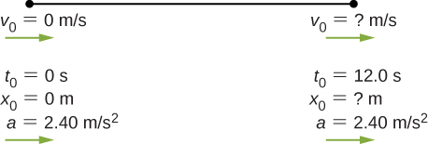

b. Knowns: 

c. the answer seems reasonable at about 172.8 m; d. 

1. **Unreasonable results** At the end of a race, a runner accelerates opposite to the motion from a velocity of 9.00 m/s at a rate of 2.00 m/s2. (a) How far does she travel in the next 5.00 s? (b) What is her final velocity? (c) Evaluate the result. Does it make sense?

Solution

a.  b. ; c. No, the final velocity is negative.

1. Blood is accelerated from rest to 30.0 cm/s in a distance of 1.80 cm by the left ventricle of the heart. (a) Make a sketch of the situation. (b) List the knowns in this problem. (c) How long does the acceleration take? To solve this part, first identify the unknown, then discuss how you chose the appropriate equation to solve for it. After choosing the equation, show your steps in solving for the unknown, checking your units. (d) Is the answer reasonable when compared with the time for a heartbeat?

Solution

a.

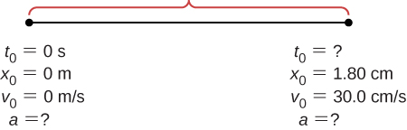

b. Knowns: 

c. 

d. yes

1. During a slap shot, a hockey player accelerates the puck from a velocity of 8.00 m/s to 40.0 m/s in the same direction. If this shot takes  what is the distance over which the puck accelerates?

Solution

; 

1. A powerful motorcycle can accelerate from rest to 26.8 m/s (100 km/h) in only 3.90 s. (a) What is its average acceleration? (b) Assuming constant acceleration, how far does it travel in that time?

Solution

a.  b. 

1. Freight trains can produce only relatively small accelerations. (a) What is the final velocity of a freight train that accelerates at a rate of for 8.00 min, starting with an initial velocity of 4.00 m/s? (b) If the train can slow down at a rate of  how long will it take to come to a stop from this velocity? (c) How far will it travel in each case?

Solution

a. 

b. 

c. for part a.:  for part b.: 

1. A fireworks shell is accelerated from rest to a velocity of 65.0 m/s over a distance of 0.250 m. (a) Calculate the acceleration. (b) How long did the acceleration last?

Solution

a. 

b. 

1. A swan on a lake gets airborne by flapping its wings and running on top of the water. (a) If the swan must reach a velocity of 6.00 m/s to take off and it accelerates from rest at an average rate of  how far will it travel before becoming airborne? (b) How long does this take?

Solution

a. 

b. 

1. A woodpecker’s brain is specially protected from large accelerations by tendon-like attachments inside the skull. While pecking on a tree, the woodpecker’s head comes to a stop from an initial velocity of 0.600 m/s in a distance of only 2.00 mm. (a) Find the acceleration in meters per second squaredand in multiples of *g*, where *g* = 9.80 m/s2. (b) Calculate the stopping time. (c) The tendons cradling the brain stretch, making its stopping distance 4.50 mm (greater than the head and, hence, less acceleration of the brain). What is the brain’s acceleration, expressed in multiples of *g*?

Solution

a. 

b. 

c. 

1. An unwary football player collides with a padded goalpost while running at a velocity of 7.50 m/s and comes to a full stop after compressing the padding and his body 0.350 m. (a) What is his acceleration? (b) How long does the collision last?

Solution

a. 

b. 

1. A care package is dropped out of a cargo plane and lands in the forest. If we assume the care package speed on impact is 54 m/s (123 mph), then what is its acceleration? Assume the trees and snow stops it over a distance of 3.0 m.

Solution

Knowns:  We want *a*, so we can use this equation: .

1. An express train passes through a station. It enters with an initial velocity of 22.0 m/s and accelerates opposite to the motion at a rate of  as it goes through. The station is 210.0 m long. (a) How fast is it going when the nose leaves the station? (b) How long is the nose of the train in the station? (c) If the train is 130 m long, what is the velocity of the end of the train as it leaves? (d) When does the end of the train leave the station?

Solution

a. 

b. 

c. 

d. 

1. **Unreasonable results** Dragsters can actually reach a top speed of 145.0 m/s in only 4.45 s. (a) Calculate the average acceleration for such a dragster. (b) Find the final velocity of this dragster starting from rest and accelerating at the rate found in (a) for 402.0 m (a quarter mile) without using any information on time. (c) Why is the final velocity greater than that used to find the average acceleration? (*Hint*: Consider whether the assumption of constant acceleration is valid for a dragster. If not, discuss whether the acceleration would be greater at the beginning or end of the run and what effect that would have on the final velocity.)

Solution

a. 

b. 

c.  because the assumption of constant acceleration is not valid for a dragster. A dragster changes gears and would have a greater acceleration in first gear than second gear than third gear, and so on. The acceleration would be greatest at the beginning, so it would not be accelerating at  during the last few meters, but substantially less, and the final velocity would be less than 

1. Calculate the displacement and velocity at times of (a) 0.500 s, (b) 1.00 s, (c) 1.50 s, and (d) 2.00 s for a ball thrown straight up with an initial velocity of 15.0 m/s. Take the point of release to be.

Solution

a. ;

b. ;

c. 

and the ball is almost at the top;

d.

and the ball has begun to drop

1. Calculate the displacement and velocity at times of (a) 0.500 s, (b) 1.00 s, (c) 1.50 s, (d) 2.00 s, and (e) 2.50 s for a rock thrown straight down with an initial velocity of 14.0 m/s from the Verrazano Narrows Bridge in New York City. The roadway of this bridge is 70.0 m above the water.

Solution

a. ****;

b. ****;

c. ****;

d. ****;

e. 

1. A basketball referee tosses the ball straight up for the starting tip-off. At what velocity must a basketball player leave the ground to rise 1.25 m above the floor in an attempt to get the ball?

Solution



1. A rescue helicopter is hovering over a person whose boat has sunk. One of the rescuers throws a life preserver straight down to the victim with an initial velocity of 1.40 m/s and observes that it takes 1.8 s to reach the water. (a) List the knowns in this problem. (b) How high above the water was the preserver released? Note that the downdraft of the helicopter reduces the effects of air resistance on the falling life preserver, so that an acceleration equal to that of gravity is reasonable.

Solution

a. Knowns: ;

b. and the origin is at the rescuers, who are 18.4 m above the water.

1. **Unreasonable results** A dolphin in an aquatic show jumps straight up out of the water at a velocity of 15.0 m/s. (a) List the knowns in this problem. (b) How high does his body rise above the water? To solve this part, first note that the final velocity is now a known, and identify its value. Then, identify the unknown and discuss how you chose the appropriate equation to solve for it. After choosing the equation, show your steps in solving for the unknown, checking units, and discuss whether the answer is reasonable. (c) How long a time is the dolphin in the air? Neglect any effects resulting from his size or orientation.

Solution

a. Knowns: ;

b.  and an 11.5-m height seems unreasonable, which is about 38 ft; c.  to the apex times 2 gives 3.0 s in the air

1. A diver bounces straight up from a diving board, avoiding the diving board on the way down, and falls feet first into a pool. She starts with a velocity of 4.00 m/s and her takeoff point is 1.80 m above the pool. (a) What is her highest point above the board? (b) How long a time are her feet in the air? (c) What is her velocity when her feet hit the water?

Solution

a. ; b. to the apex  times 2 to the board = 0.82 s from the board to the water  , solution to quadratic equation gives 1.13 s; c. 

1. (a) Calculate the height of a cliff if it takes 2.35 s for a rock to hit the ground when it is thrown straight up from the cliff with an initial velocity of 8.00 m/s. (b) How long a time would it take to reach the ground if it is thrown straight down with the same speed?

Solution

a. ;

b. subtract the time to the apex times 2: 

1. A very strong, but inept, shot putter puts the shot straight up vertically with an initial velocity of 11.0 m/s. How long a time does he have to get out of the way if the shot was released at a height of 2.20 m and he is 1.80 m tall?

Solution

Time to the apex:  times 2 equals 2.24 s to a height of 2.20 m. To 1.80 m in height is an additional 0.40 m. .

Take the positive root, so the time to go the additional 0.4 m is 0.04 s. Total time is .]

1. You throw a ball straight up with an initial velocity of 15.0 m/s. It passes a tree branch on the way up at a height of 7.0 m. How much additional time elapses before the ball passes the tree branch on the way back down?

Solution



Velocity at the branch: 

Time to the apex: 

Total additional time: 1.92 s

1. A kangaroo can jump over an object 2.50 m high. (a) Considering just its vertical motion, calculate its vertical speed when it leaves the ground. (b) How long a time is it in the air?

Solution

a. ; b.  times 2 gives 1.44 s in the air

1. Standing at the base of one of the cliffs of Mt. Arapiles in Victoria, Australia, a hiker hears a rock break loose from a height of 105.0 m. He can’t see the rock right away, but then does, 1.50 s later. (a) How far above the hiker is the rock when he can hear it? (b) How much time does he have to move before the rock hits his head?

Solution

a. ; b. time from 105 m to ground: , so time to move out of the way is 4.63 s – 1.50 s = 3.13 s

1. There is a 250-m-high cliff at Half Dome in Yosemite National Park in California. Suppose a boulder breaks loose from the top of this cliff. (a) How fast will it be going when it strikes the ground? (b) Assuming a reaction time of 0.300 s, how long a time will a tourist at the bottom have to get out of the way after hearing the sound of the rock breaking loose (neglecting the height of the tourist, which would become negligible anyway if hit)? The speed of sound is 335.0 m/s on this day.

Solution

a. ; b. time heard after rock begins to fall: , time to reach the ground: , 

1. The acceleration of a particle varies with time according to the equation  . Initially, the velocity and position are zero. (a) What is the velocity as a function of time? (b) What is the position as a function of time?

Solution

a.  Since ,  b. 

 ; therefore, 

1. Between *t* = 0 and *t* = *t*0, a rocket moves straight upward with an acceleration given by , where *A* and *B* are constants. (a) If *x* is in meters and *t* is in seconds, what are the units of *A* and *B*? (b) If the rocket starts from rest, how does the velocity vary between *t* = 0 and *t* = *t*0? (c) If its initial position is zero, what is the rocket’s position as a function of time during this same time interval?

Solution

a. ;

b. ;

c. 

1. The velocity of a particle moving along the *x-*axis varies with time according to  where *A* = 2 m/s, *B* = 0.25 m, and  Determine the acceleration and position of the particle at *t*  = 2.0 s and *t* = 5.0 s. Assume that 

Solution

 The acceleration is continuous over the interval



1. A particle at rest leaves the origin with its velocity increasing with time according to *v*(*t*) = 3.2*t* m/s. At 5.0 s, the particle’s velocity starts decreasing according to [16.0 – 1.5(*t* – 5.0)] m/s. This decrease continues until *t* = 11.0 s, after which the particle’s velocity remains constant at 7.0 m/s. (a) What is the acceleration of the particle as a function of time? (b) What is the position of the particle at *t* = 2.0 s, *t* = 7.0 s, and *t* = 12.0 s?

Solution

a. ;

b. 

**Additional Problems**

1. Professional baseball player Nolan Ryan could pitch a baseball at approximately 160.0 km/h. At that average velocity, how long did it take a ball thrown by Ryan to reach home plate, which is 18.4 m from the pitcher’s mound? Compare this with the average reaction time of a human to a visual stimulus, which is 0.25 s.

Solution



This speed is just 1.5 s greater than the average reaction time of a human

1. An airplane leaves Chicago and makes the 3000-km trip to Los Angeles in 5.0 h. A second plane leaves Chicago one-half hour later and arrives in Los Angeles at the same time. Compare the average velocities of the two planes. Ignore the curvature of Earth and the difference in altitude between the two cities.

Solution

Take west to be the positive direction.

1st plane: 

2nd plane 

1. **Unreasonable Results** A cyclist rides 16.0 km east, then 8.0 km west, then 8.0 km east, then 32.0 km west, and finally 11.2 km east. If his average velocity is 24 km/h, how long did it take him to complete the trip? Is this a reasonable time?

Solution

The total displacement is . For the average velocity to be a positive number, the elapsed time would have to be negative, which can’t be. Therefore, the cyclist’s average velocity is negative and the statement of the problem is incorrect.

1. An object has an acceleration of  At its velocity is  Determine the object’s velocities at  and 

Solution

 ,  ; 

1. A particle moves along the *x*-axis according to the equation  m. What are the velocity and acceleration at  s and  s?

Solution

; ;  for all *t*

1. A particle moving at constant acceleration has velocities of 2.0 m/s at *t* =2.0 s and –7.6 m/s at *t* = 5.2 s. What is the acceleration of the particle?

Solution



1. A train is moving up a steep grade at constant velocity (see following figure) when its caboose breaks loose and starts rolling freely along the track. After 5.0 s, the caboose is 30 m behind the train. What is the acceleration of the caboose?

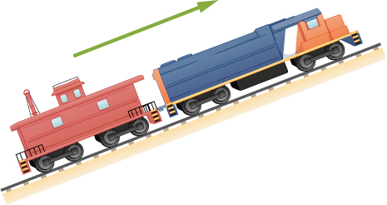

Solution

We take the origin at the point of separation of the caboose and train. The positive direction is up the track. The equation for the caboose is  with  the velocity of the train. At  s the position of the caboose on the track with respect to the origin is  where  is the velocity of the train, as the problem states the caboose is 30 m from the train in the negative direction. Substituting into the equation we have  Solving for acceleration gives  Note the velocity of the train does not enter into the final solution.

1. An electron is moving in a straight line with a velocity of  m/s. It enters a region 5.0 cm long where it undergoes an acceleration of  along the same straight line. (a) What is the electron’s velocity when it emerges from this region? b) How long does the electron take to cross the region?

Solution

a. 

b. 

1. An ambulance driver is rushing a patient to the hospital. While traveling at 72 km/h, she notices the traffic light at the upcoming intersections has turned amber. To reach the intersection before the light turns red, she must travel 50 m in 2.0 s. (a) What minimum acceleration must the ambulance have to reach the intersection before the light turns red? (b) What is the speed of the ambulance when it reaches the intersection?

Solution

a.   

b. 

1. A motorcycle that is slowing down uniformly covers 2.0 successive km in 80 s and 120 s, respectively. Calculate (a) the acceleration of the motorcycle and (b) its velocity at the beginning and end of the 2-km trip.

Solution

;  solve simultaneously to get  and  which is  Velocity at the end of the trip is 

1. A cyclist travels from point A to point B in 10 min. During the first 2.0 min of her trip, she maintains a uniform acceleration of  She then travels at constant velocity for the next 5.0 min. Next, she accelerates opposite to the motion at a constant rate so that she comes to a rest at point B 3.0 min later. (a) Sketch the velocity-versus-time graph for the trip. (b) What is the acceleration during the last 3 min? (c) How far does the cyclist travel?

Solution

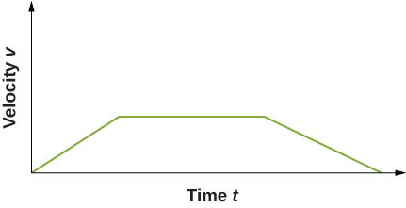

b. Her velocity during the second leg of the trip is   c. Distance of the third leg: 

Total distance: 

1. Two trains are moving at 30 m/s in opposite directions on the same track. The engineers see simultaneously that they are on a collision course and apply the brakes when they are 1000 m apart. Assuming both trains have the same acceleration, what must this acceleration be if the trains are to stop just short of colliding?

Solution



1. A 10.0-m-long truck moving with a constant velocity of 97.0 km/h passes a 3.0-m-long car moving with a constant velocity of 80.0 km/h. How much time elapses between the moment the front of the truck is even with the back of the car and the moment the back of the truck is even with the front of the car?

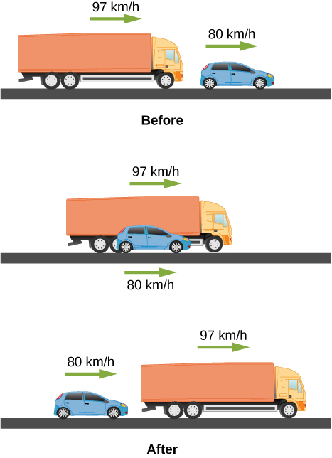

Solution

The car can be the frame of reference so that the truck passes at . The front of the truck undergoes displacement relative to the car with velocity 

; 

1. A police car waits in hiding slightly off the highway. A speeding car is spotted by the police car doing 40 m/s. At the instant the speeding car passes the police car, the police car accelerates from rest at 4 m/s2 to catch the speeding car. How long does it take the police car to catch the speeding car?

Solution

Equation for the speeding car: This car has a constant velocity, which is the average velocity, and is not accelerating, so use the equation for displacement with :; Equation for the police car: This car is accelerating, so use the equation for displacement with  and , since the police car starts from rest: ; Now we have an equation of motion for each car with a common parameter, which can be eliminated to find the solution. In this case, we solve for . Step 1, eliminating : ; Step 2, solving for : . The speeding car has a constant velocity of 40 m/s, which is its average velocity. The acceleration of the police car is 4 m/s2. Evaluating *t*, the time for the police car to reach the speeding car, we have 

1. Pablo is running in a half marathon at a velocity of 3 m/s. Another runner, Jacob, is 50 meters behind Pablo with the same velocity. Jacob begins to accelerate at 0.05 m/s2. (a) How long does it take Jacob to catch Pablo? (b) What is the distance covered by Jacob? (c) What is the final velocity of the Jacob?

Solution

a. Common to each runner is their position at a later time *t.* Choose the origin to be Jacob at *t* = 0. Pablo: .

Jacob: .  . ; b. 

c. 

1. **Unreasonable results** A runner approaches the finish line and is 75 m away; her speed at this position is 8 m/s. She accelerates opposite to the motion at this point at 0.5 m/s2. How long does it take her to cross the finish line from 75 m away? Is this reasonable?

Solution

At this acceleration she comes to a full stop in  but the distance covered is  which is less than the distance she is away from the finish line, so she never finishes the race.

1. An airplane accelerates at 5.00 m/s2 for 30.0 s. During this time, it covers a distance of 10.0 km. What are the initial and final velocities of the airplane?

Solution





1. Compare the distance traveled of an object that undergoes a change in velocity that is twice its initial velocity with an object that changes its velocity by four times its initial velocity over the same time period. The accelerations of both objects are constant.

Solution



 

1. An object is moving east with a constant velocity and is at position . (a) With what acceleration must the object have for its total displacement to be zero at a later time *t* ? (b) What is the physical interpretation of the solution in the case for ?

Solution

a. 

 ; b. The total displacement is zero when the object has arrived back at its starting point. As the acceleration gets less, it takes more time for the object to return to its starting point. As , acceleration goes to zero, which means it would take an infinite amount of time for the object to arrive back at its starting point.

1. A ball is thrown straight up. It passes a 2.00-m-high window 7.50 m off the ground on its path up and takes 1.30 s to go past the window. What was the ball’s initial velocity?

Solution



 velocity at the bottom of the window.





1. A coin is dropped from a hot-air balloon that is 300 m above the ground and rising at 10.0 m/s upward. For the coin, find (a) the maximum height reached, (b) its position and velocity 4.00 s after being released, and (c) the time before it hits the ground.

Solution

a. ;

b. , which is a height of 261.6 m, ;

c. 

1. A soft tennis ball is dropped onto a hard floor from a height of 1.50 m and rebounds to a height of 1.10 m. (a) Calculate its velocity just before it strikes the floor. (b) Calculate its velocity just after it leaves the floor on its way back up. (c) Calculate its acceleration during contact with the floor if that contact lasts 3.50 ms  (d) How much did the ball compress during its collision with the floor, assuming the floor is absolutely rigid?

Solution

a. ;

b. ;

c. ;

d. 

1. **Unreasonable results**. A raindrop falls from a cloud 100 m above the ground. Neglect air resistance. What is the speed of the raindrop when it hits the ground? Is this a reasonable number?

Solution



,  which is about 99 mph, which is unreasonable

1. Compare the time in the air of a basketball player who jumps 1.0 m vertically off the floor with that of a player who jumps 0.3 m vertically.

Solution

Consider the players fall from rest at the height 1.0 m and 0.3 m.

s times 2 = 0.9 s

 s times 2 = 0.5 s

1. Suppose that a person takes 0.5 s to react and move his hand to catch an object he has dropped. (a) How far does the object fall on Earth, where (b) How far does the object fall on the Moon, where the acceleration due to gravity is 1/6 of that on Earth?

Solution

a. b.

1. A hot-air balloon rises from ground level at a constant velocity of 3.0 m/s. One minute after liftoff, a sandbag is dropped accidentally from the balloon. Calculate (a) the time it takes for the sandbag to reach the ground and (b) the velocity of the sandbag when it hits the ground.

Solution

a. The altitude of the balloon when the sandbag is released is 180 m. Take the origin at the location of the balloon at 180 m high; *y* is positive upward, so the ground is at –180 m. m



 

 taking the positive root;

b. 

1. (a) A world record was set for the men’s 100-m dash in the 2008 Olympic Games in Beijing by Usain Bolt of Jamaica. Bolt “coasted” across the finish line with a time of 9.69 s. If we assume that Bolt accelerated for 3.00 s to reach his maximum speed, and maintained that speed for the rest of the race, calculate his maximum speed and his acceleration. (b) During the same Olympics, Bolt also set the world record in the 200-m dash with a time of 19.30 s. Using the same assumptions as for the 100-m dash, what was his maximum speed for this race?

Solution

a. ;

b. Similar to a., we can substitute the different values for time and total distance:



1. An object is dropped from a height of 75.0 m above ground level. (a) Determine the distance traveled during the first second. (b) Determine the final velocity at which the object hits the ground. (c) Determine the distance traveled during the last second of motion before hitting the ground.

Solution

a. ;

b. ;

c.  initial velocity 1 s before impact 

1. A steel ball is dropped onto a hard floor from a height of 1.50 m and rebounds to a height of 1.45 m. (a) Calculate its velocity just before it strikes the floor. (b) Calculate its velocity just after it leaves the floor on its way back up. (c) Calculate its acceleration during contact with the floor if that contact lasts 0.0800 ms  (d) How much did the ball compress during its collision with the floor, assuming the floor is absolutely rigid?

Solution

a. ;

b. ;

c. ;

d. 

1. An object is dropped from a roof of a building of height *h*. During the last second of its descent, it drops a distance *h*/3. Calculate the height of the building.

Solution

 , *h* = total height and time to drop to ground

 in *t* – 1 seconds it drops 2/3*h*

 or 

 

*t* = 5.45 s and *h* = 145.5 m. Other root is less than 1 s. Check for *t* = 4.45 s  m 

**Challenge Problems**

1. In a 100-m race, the winner is timed at 11.2 s. The second-place finisher’s time is 11.6 s. How far is the second-place finisher behind the winner when she crosses the finish line? Assume the velocity of each runner is constant throughout the race.

Solution

Average velocity of second-place finisher:  When the winner crosses the line at *t* = 11.2 s, find the displacement of second-place finisher.  Therefore, the second-place finisher is  behind the winner.

1. The position of a particle moving along the *x*-axis varies with time according to  m. Find (a) the velocity and acceleration of the particle as functions of time, (b) the velocity and acceleration at *t* = 2.0 s, (c) the time at which the position is a maximum, (d) the time at which the velocity is zero, and (e) the maximum position.

Solution

a. ;

b. ; c. The slope of the position function is zero or the velocity is zero. There are two possible solutions: *t* = 0, which gives *x* = 0, or *t* = 10.0/12.0 = 0.83 s, which gives *x* = 1.16 m. The second answer is the correct choice; d. 0.83 s (e) 1.16 m

1. A cyclist sprints at the end of a race to clinch a victory. She has an initial velocity of 11.5 m/s and accelerates at a rate of 0.500 m/s2 for 7.00 s. (a) What is her final velocity? (b) The cyclist continues at this velocity to the finish line. If she is 300 m from the finish line when she starts to accelerate, how much time did she save? (c) The second-place winner was 5.00 m ahead when the winner started to accelerate, but he was unable to accelerate, and traveled at 11.8 m/s until the finish line. What was the difference in finish time in seconds between the winner and runner-up? How far back was the runner-up when the winner crossed the finish line?

Solution

a. ;

b.  , total 20.82 s without accelerating  time saved; c. time for winner is 20.82 s and time for runner-up is  so the winner finished 4.18 s ahead. When the winner crossed the finish line the runner-up was 11.80 m/s(4.18 s) = 49.32 m from the finish line.

1. In 1967, New Zealander Burt Munro set the world record for an Indian motorcycle, on the Bonneville Salt Flats in Utah, of 295.38 km/h. The one-way course was 8.00 km long. Acceleration rates are often described by the time it takes to reach 96.0 km/h from rest. If this time was 4.00 s and Burt accelerated at this rate until he reached his maximum speed, how long did it take Burt to complete the course?

Solution

 , 295.38 km/h = 82.05 m/s,  time to accelerate to maximum speed

 distance covered during acceleration

 at a constant speed

 so total time is 

This file is copyright 2016, Rice University. All Rights Reserved.